# Functions Basics 1, by Bara’a Abo-Asal

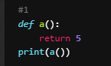

*Output expected: 5*

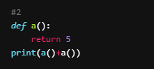

*Output expected: 10*

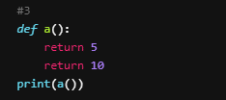

*Output expected: 5*

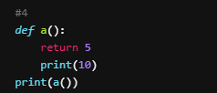

*Output expected: 5*

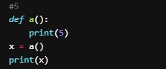

*Output expected: 5*

*Error to the last line because there is nth inside x, because we didn’t make return from the function to be stored in x*

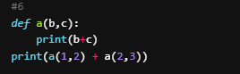

*Output expected: 3, 5*

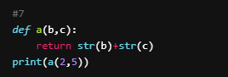

*Output expected: 25*

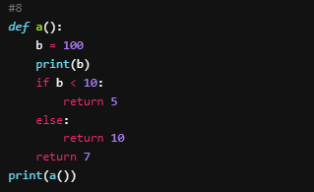

*Output expected: 100, 10*

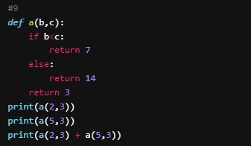

*Output expected: 7, 14, 21*

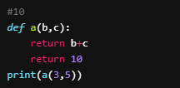

*Output expected: 8*

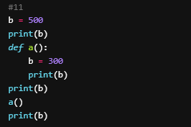

*Output expected: 500, 500, 300, 500*

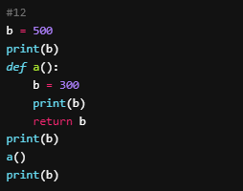

*Output expected: 500, 500, 300, 500*

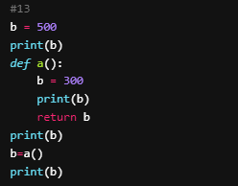

*Output expected: 500, 500, 300, 300*

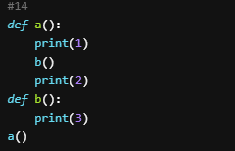

*Output expected: 1, 3, 2*

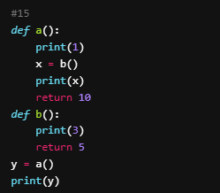

*Output expected: 1, 3, 5, 10*